# **10.4 Project: Install Linux for PromisedLand**

1. A brief exploration of your Linux distribution.

For this migration, the Ubuntu distribution will be used due to its stability, ease of use, and large community support. Ubuntu also has a wide range of pre-built packages and software, making it easier to install and configure additional software.

1. Explanation of why you chose that distribution.

We use Ubuntu since Ubuntu has a wide range of pre-built packages and software, making it easier to install and configure additional software.

1. Demonstration of how your implementation correlates with PromisedLand’s infrastructure.

**-Add hostname**

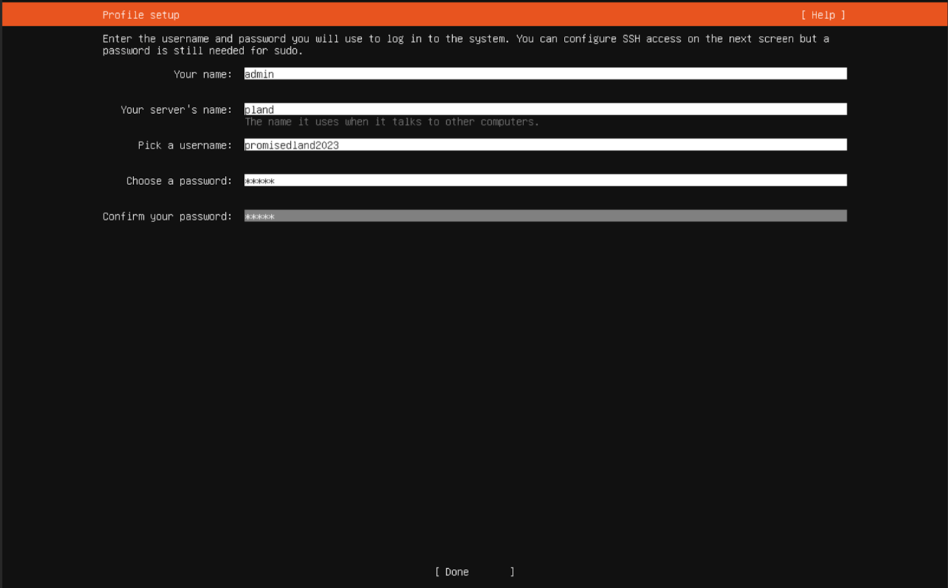

**-Add networking**

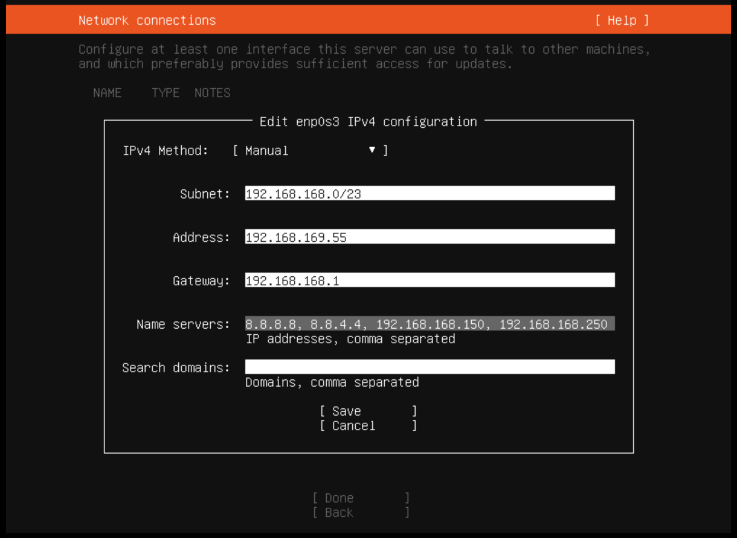

**-Share file Configuration**

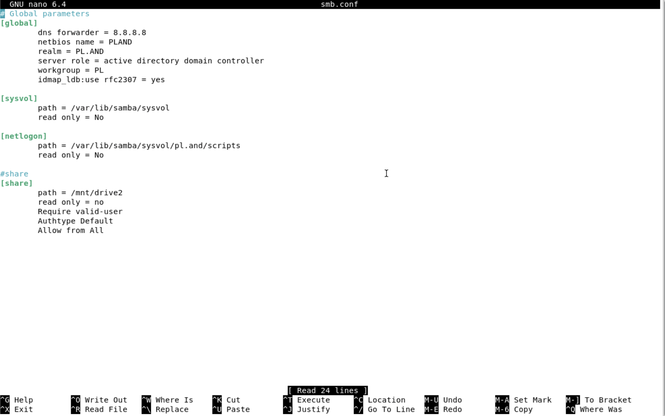

**-Share file Folder**

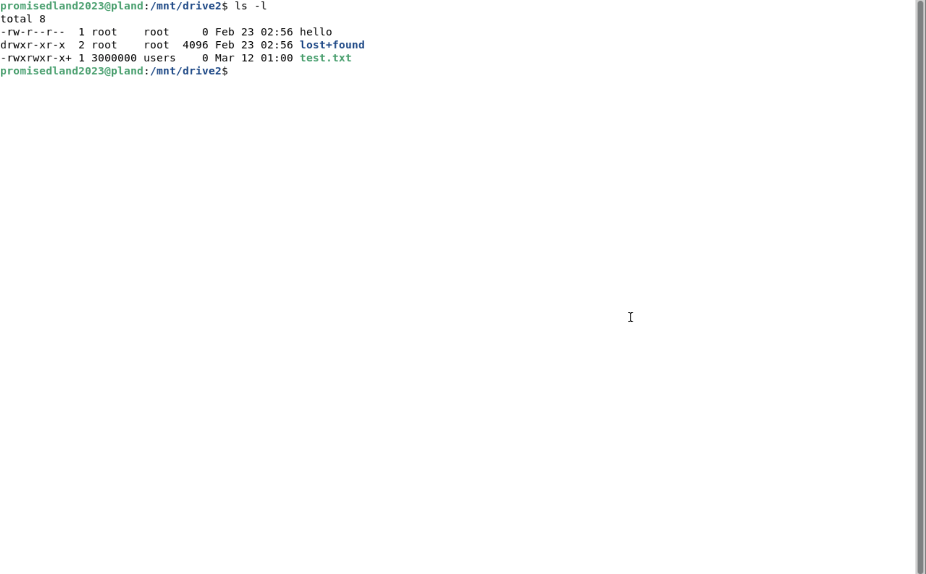

**-Share file Windows (** **\\192.168.169.55\share** **for windows or smb://192.168.169.55/share for MacBook )**

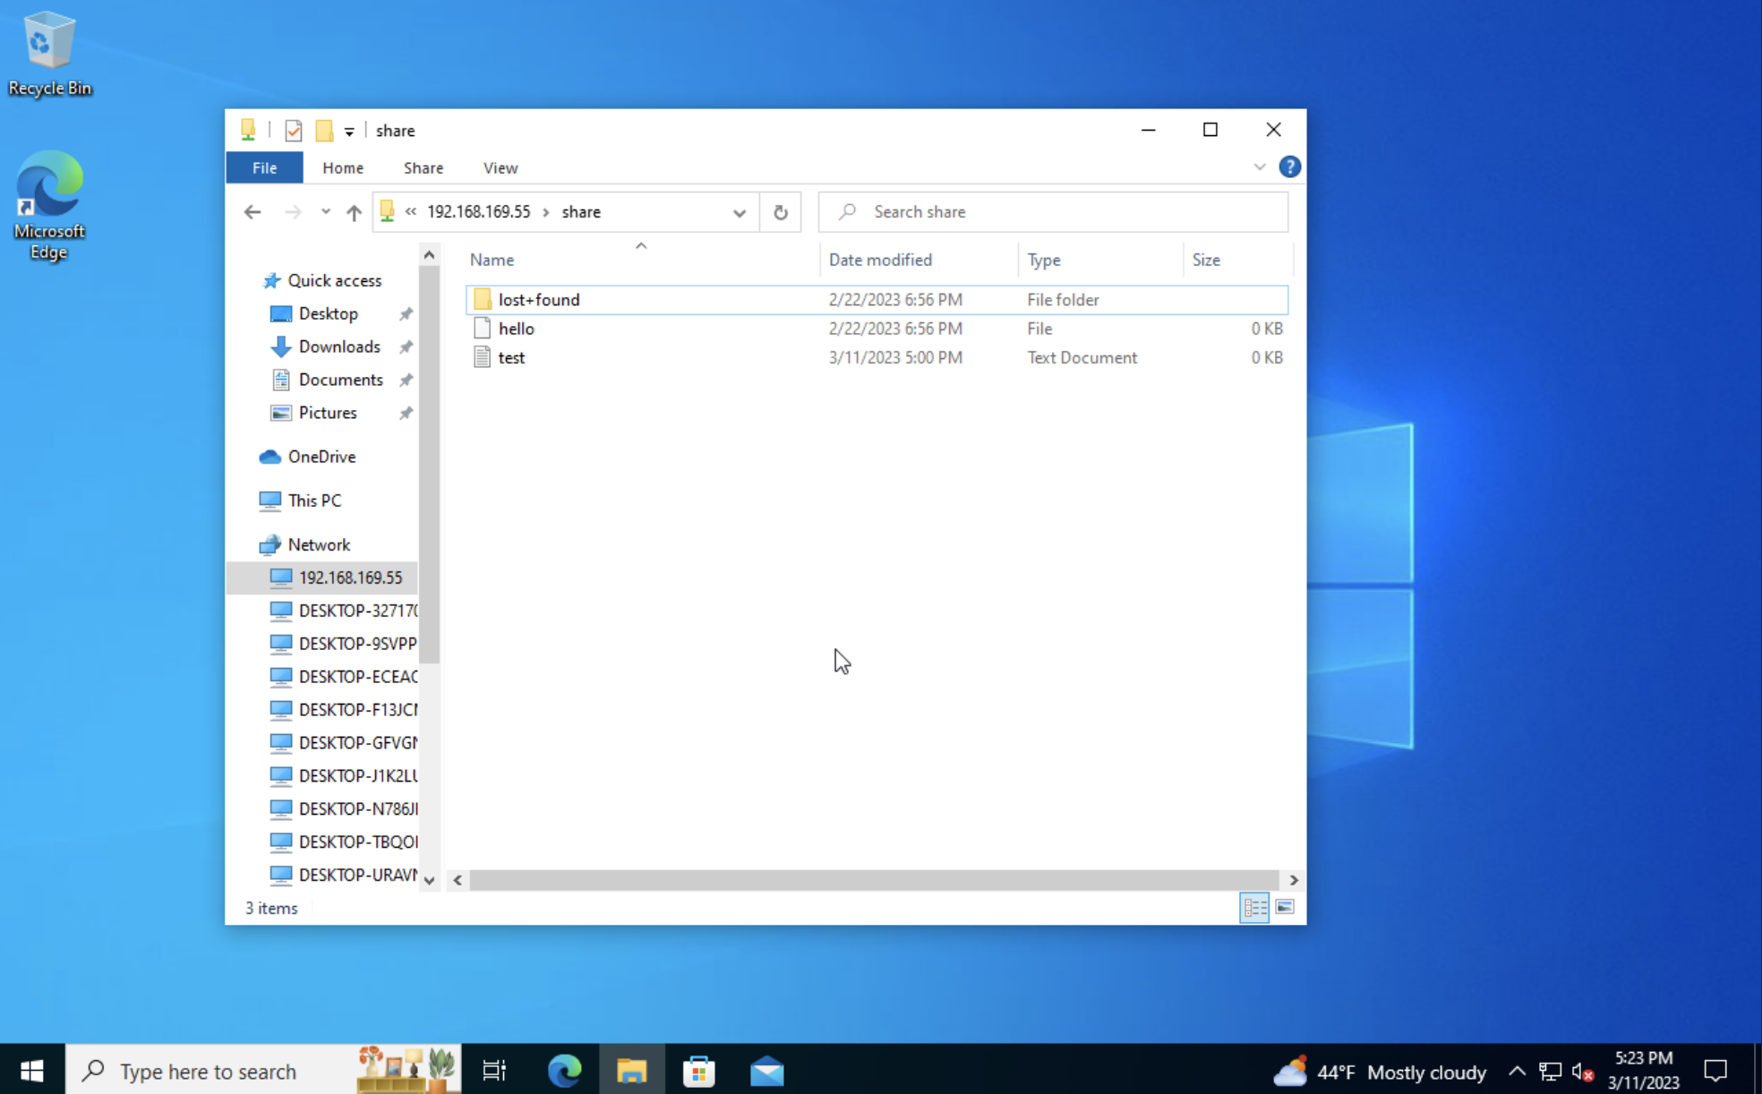

**-Share file MacBook (** **\\192.168.169.55\share** **for windows or smb://192.168.169.55/share for MacBook )**

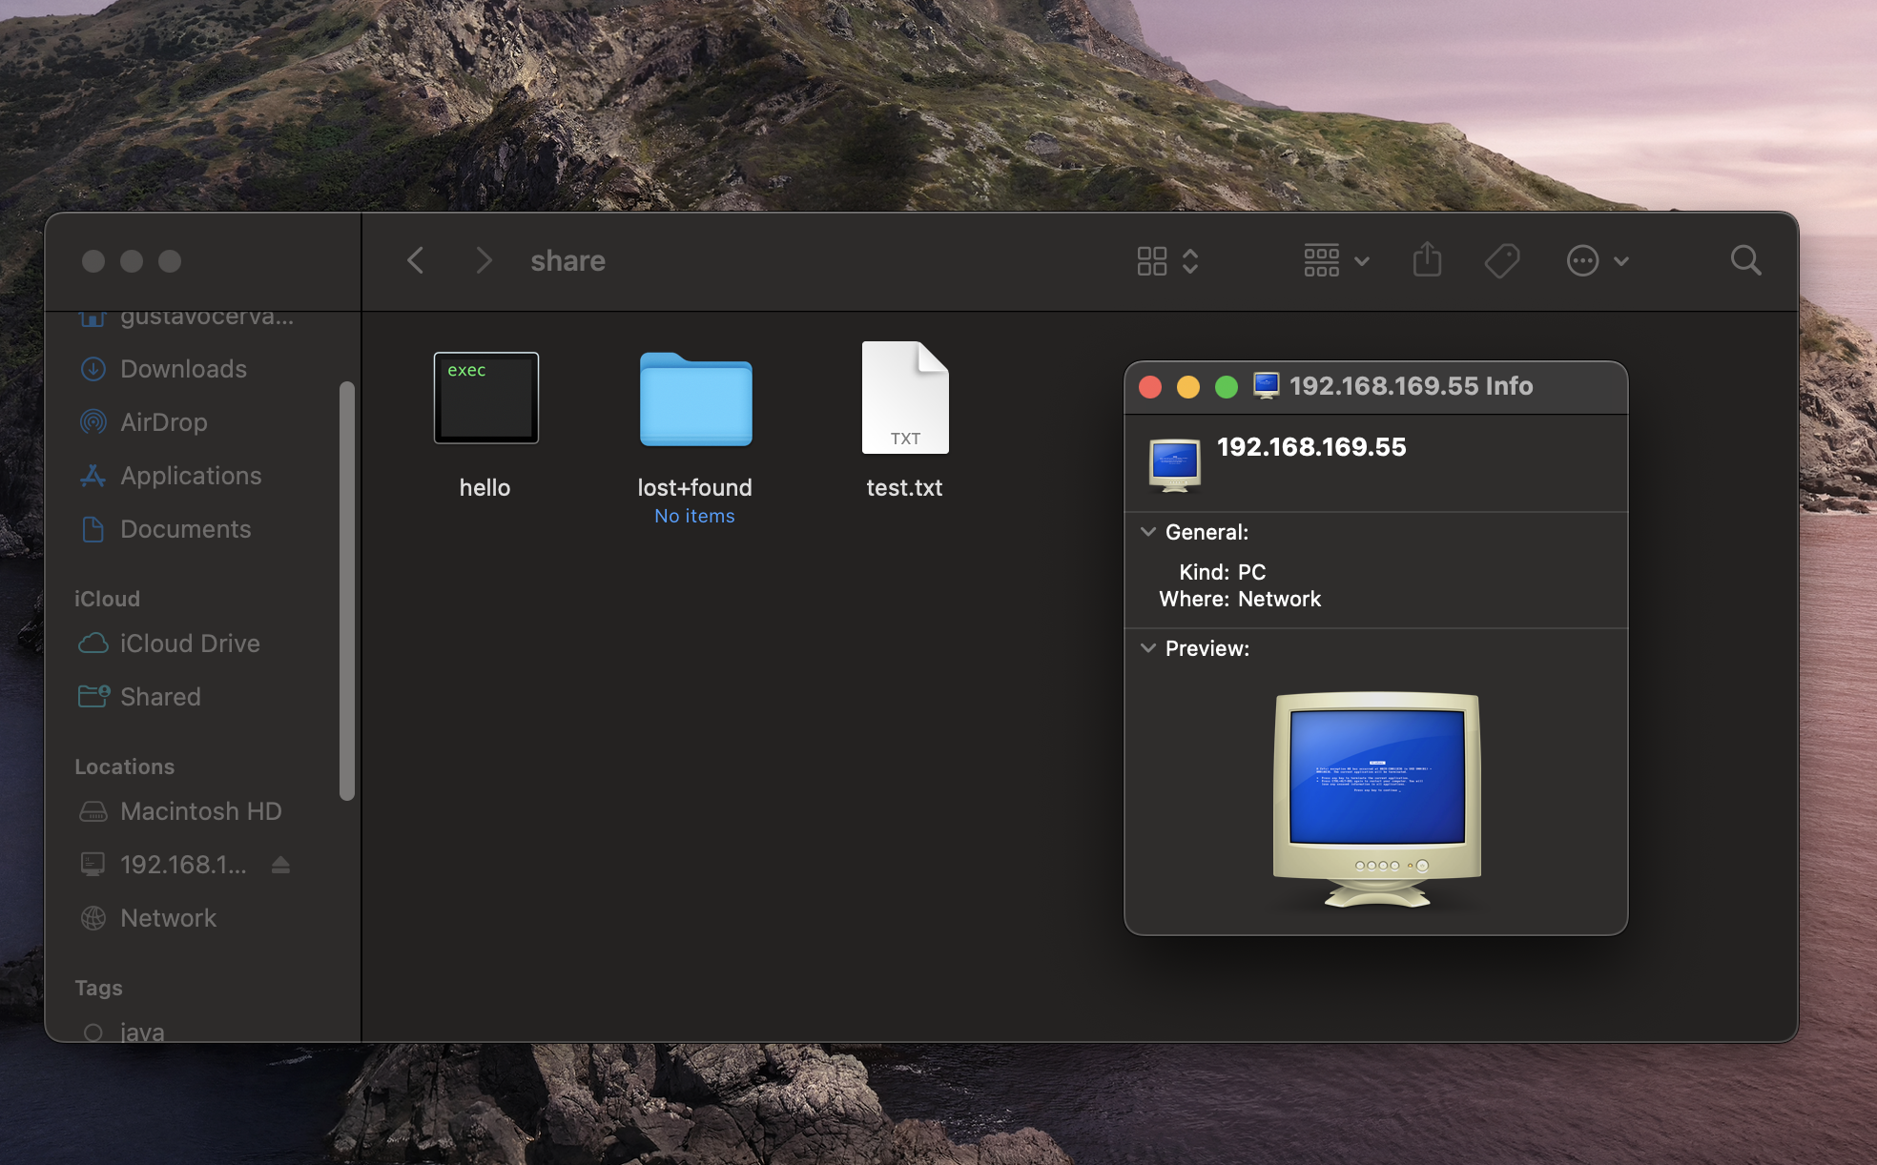

**-Remote Desktop Configuration**

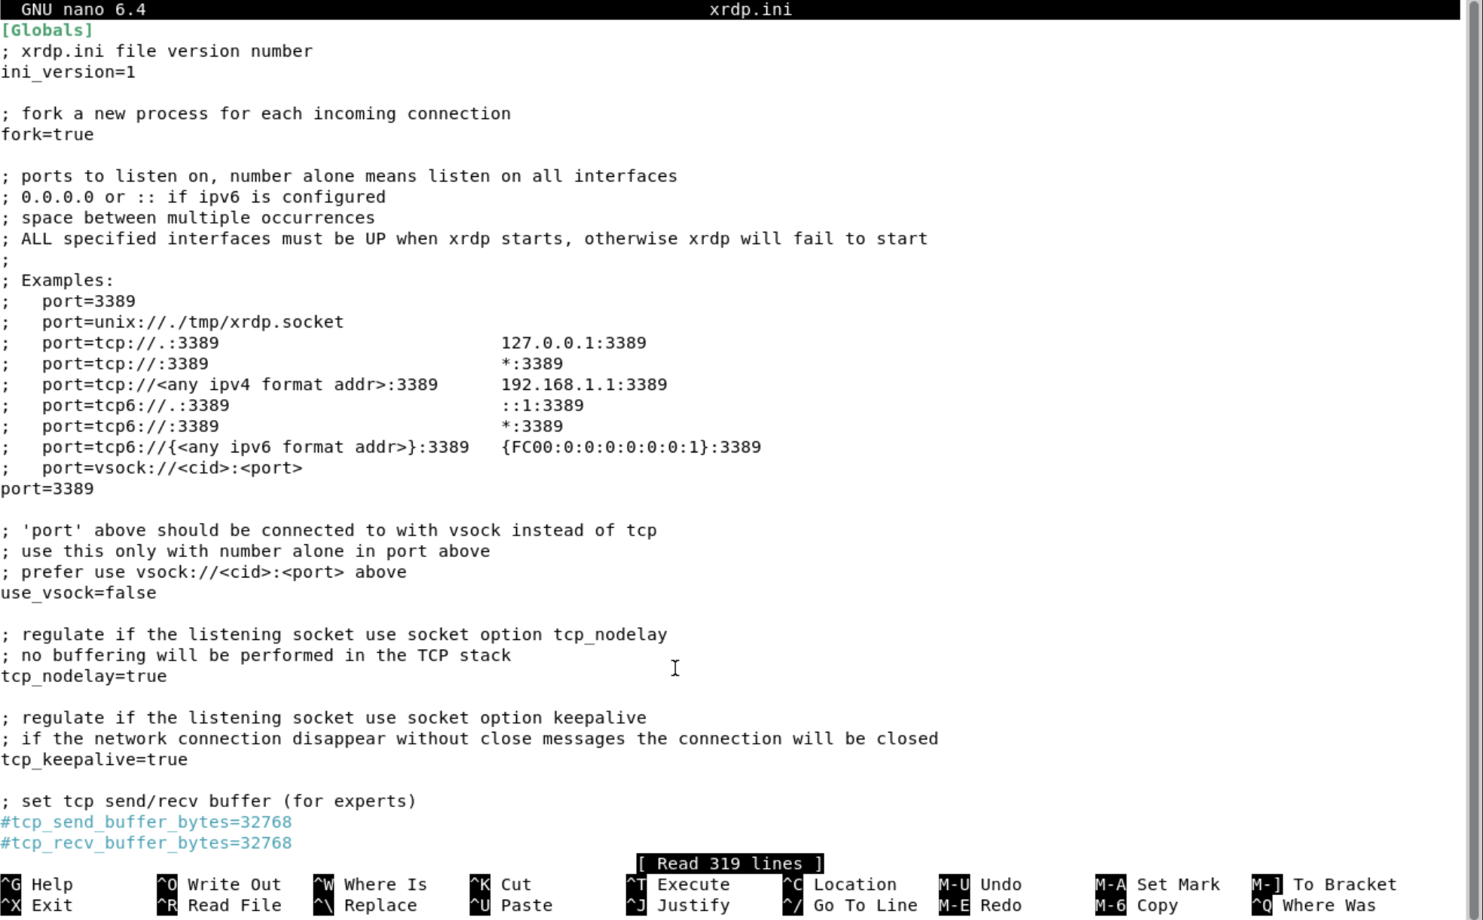

**-Remote Desktop from Windows ( 192.168.169.55 VNC 5900 for windows or 192.168.169.55:5900 for MacBook )**

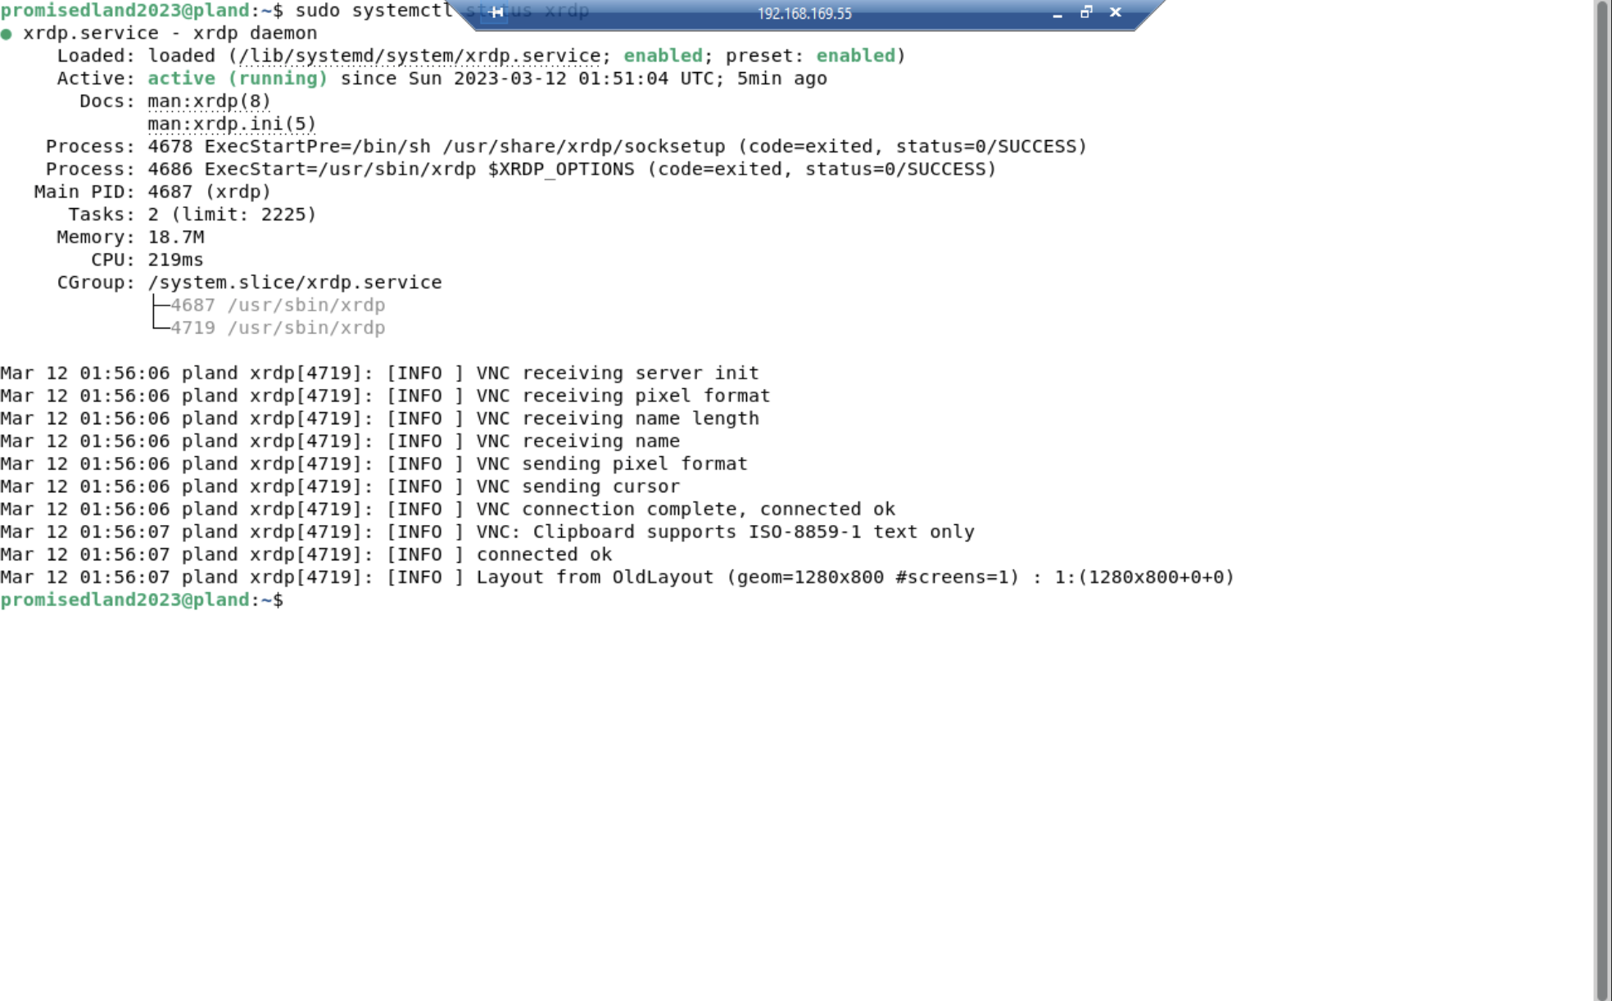

-Remote Desktop from MacBook ( 192.168.169.55 VNC 5900 for windows or 192.168.169.55:5900 for MacBook )

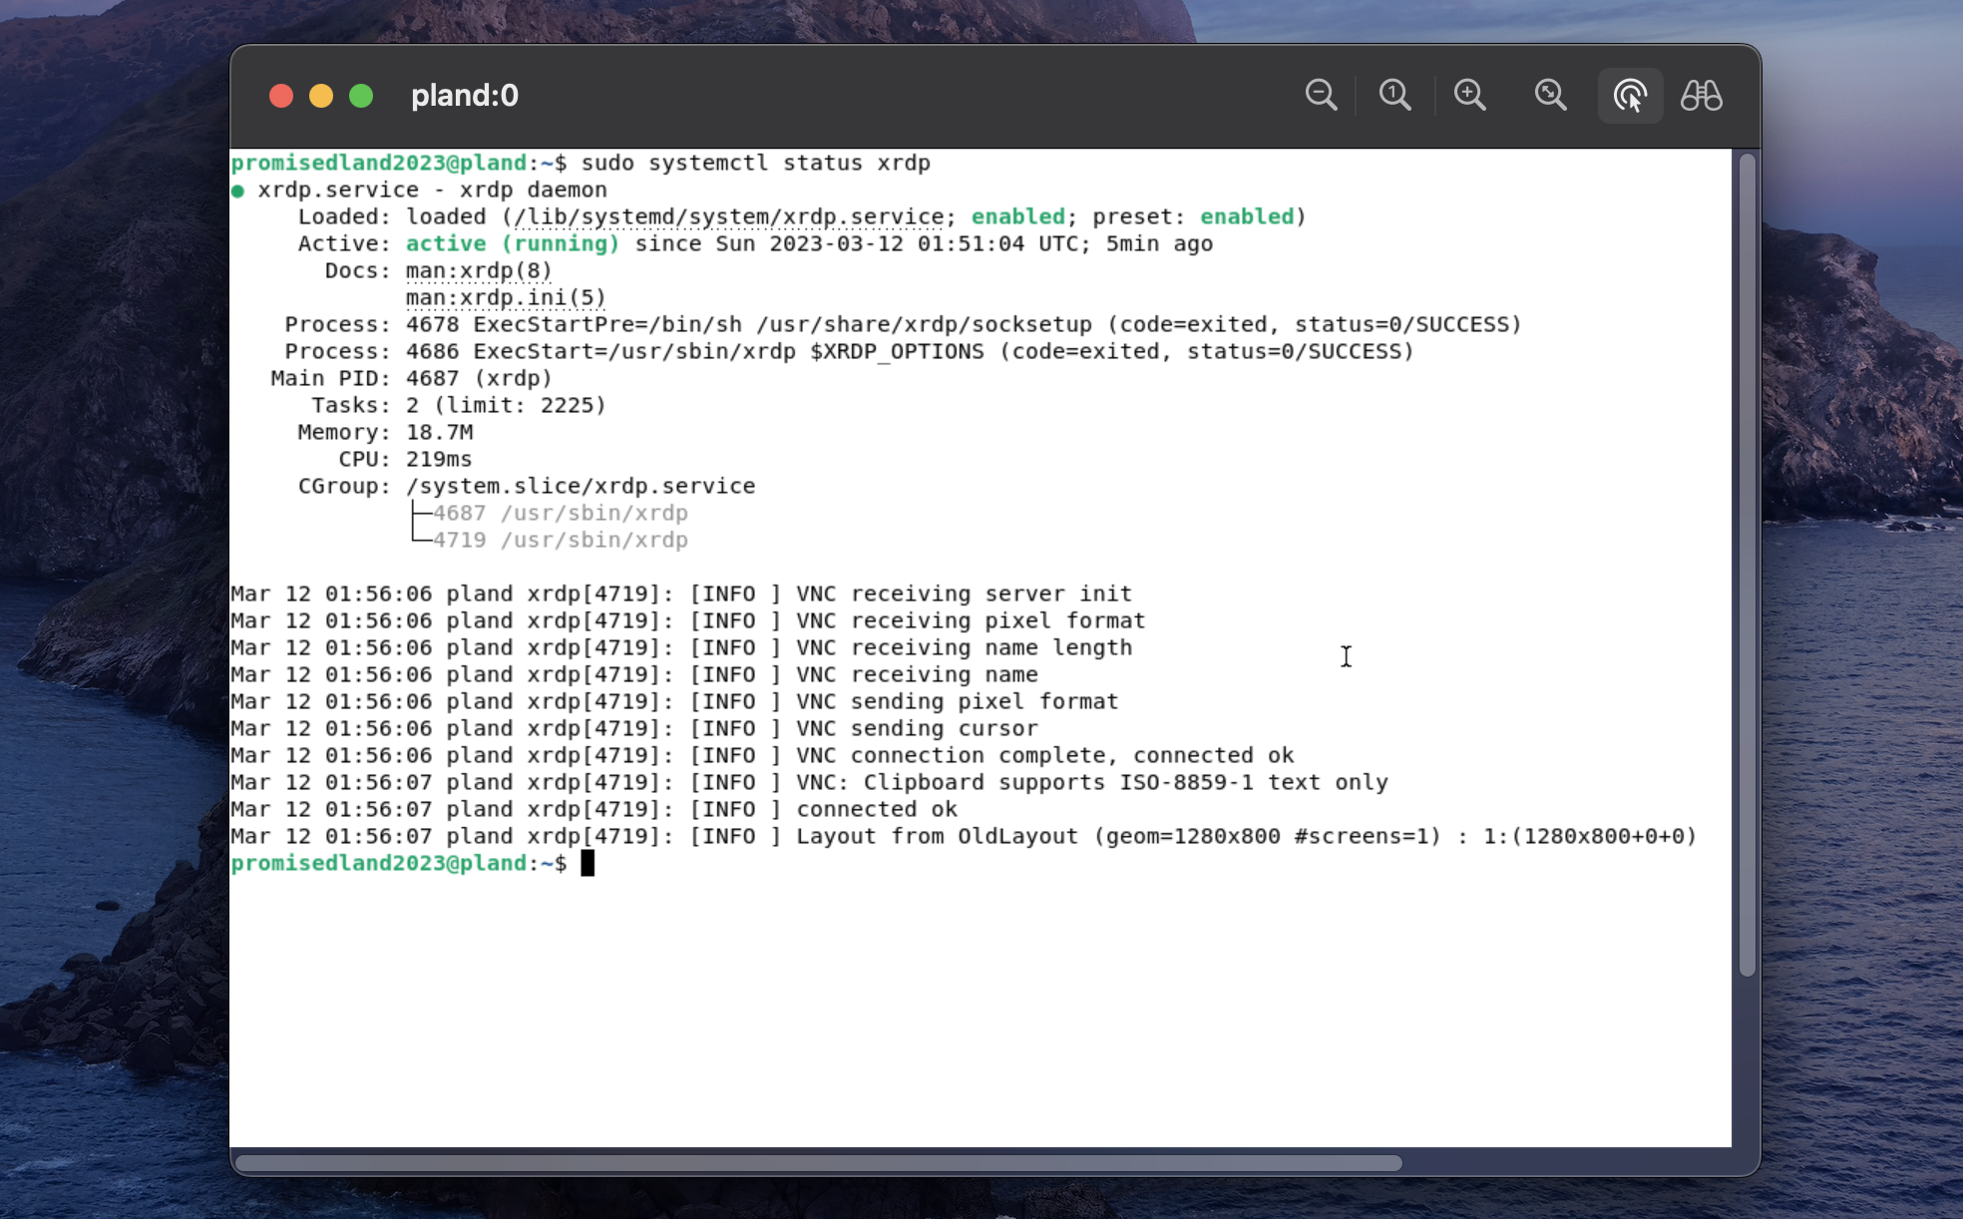

**-Web Server Configuration Apache2 (** [**https://pl.and**](https://pl.and) **or** [**https://192.168.169.55**](https://192.168.169.55) **or** [**http://pl.and**](http://pl.and) **or** [**http://192.168.169.55**](http://192.168.169.55) **)**

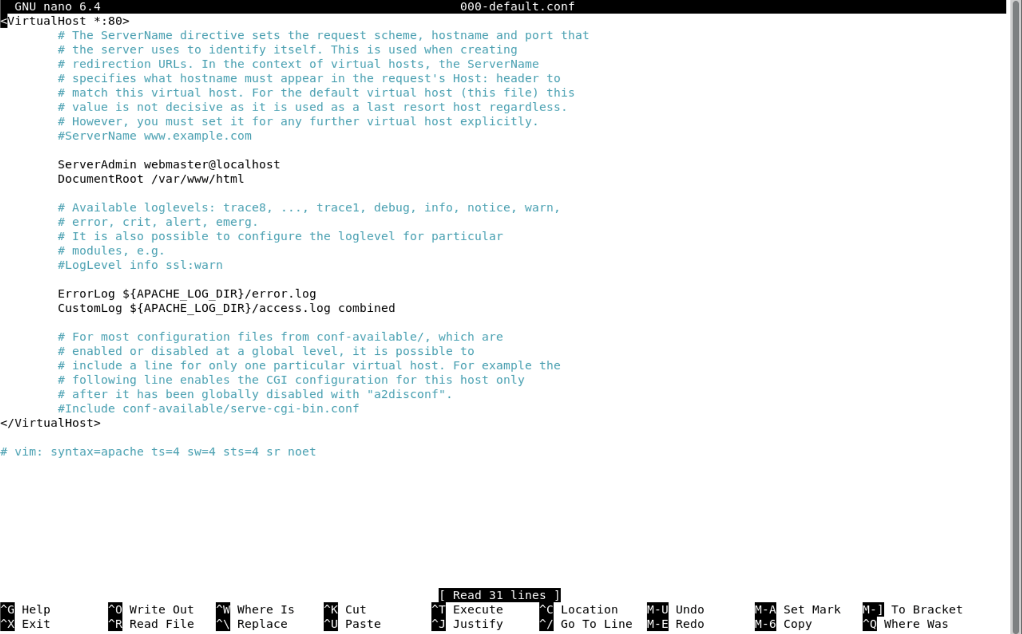

**-Web Server from Windows (** [**https://pl.and**](https://pl.and) **or** [**https://192.168.169.55**](https://192.168.169.55) **or** [**http://pl.and**](http://pl.and) **or** [**http://192.168.169.55**](http://192.168.169.55) **)**

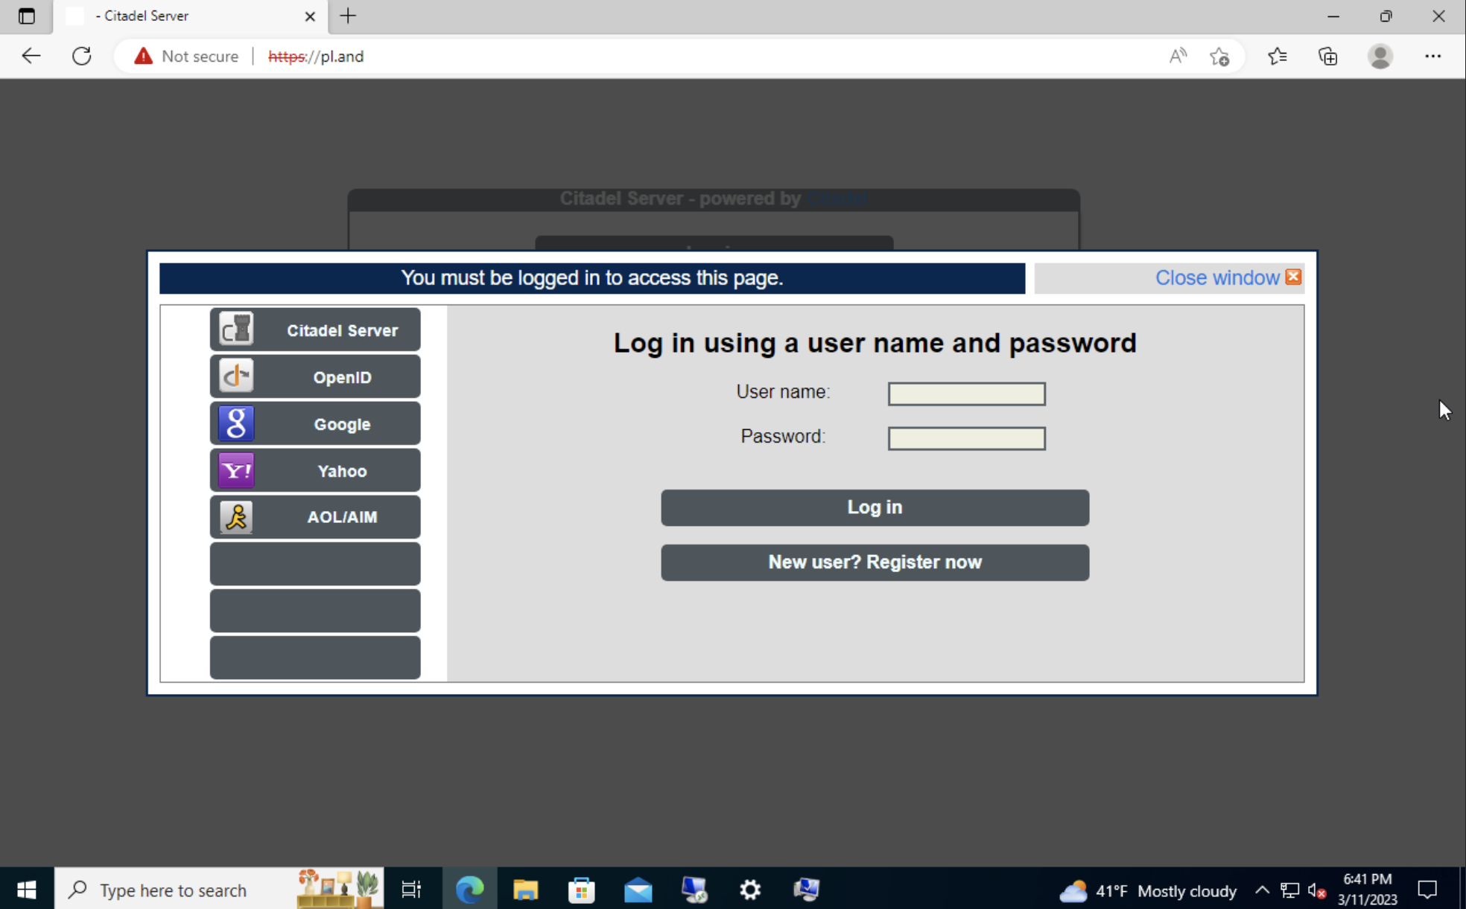

**-Monitor Configuration Renderer add in net plan**

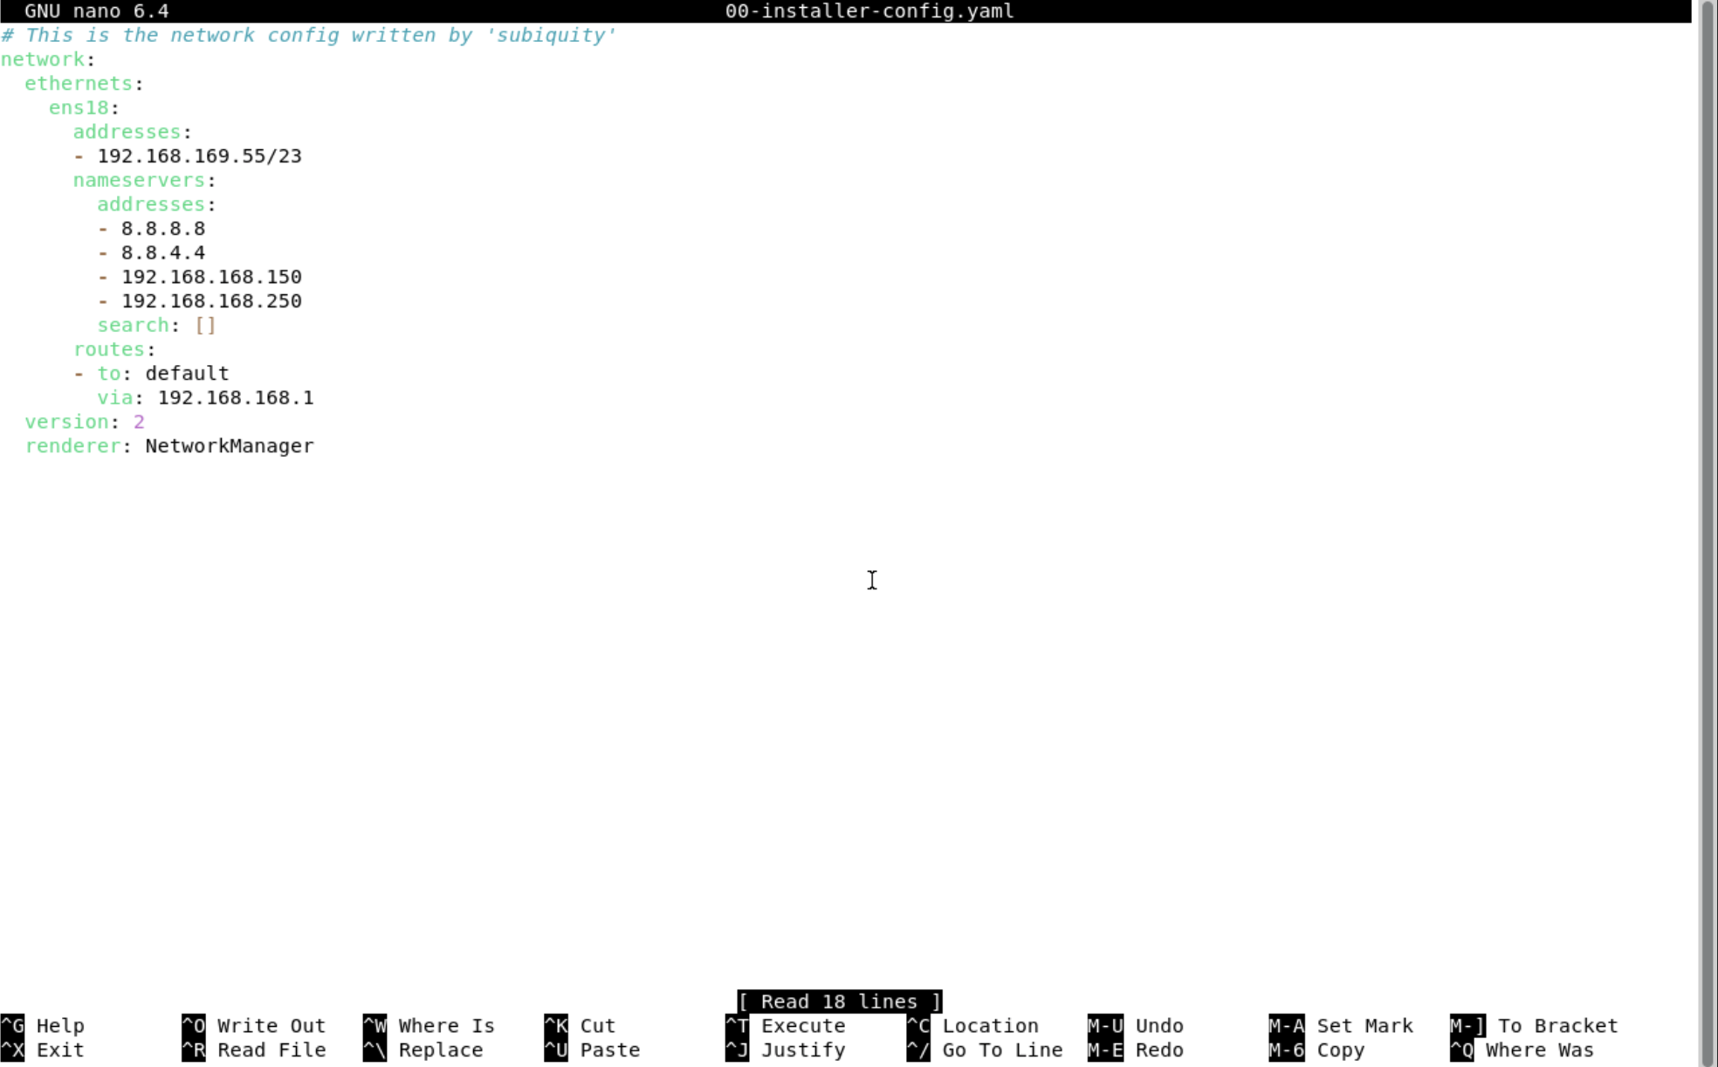

**-Monitoring Users (** [**https://192.168.169.55:9090**](https://192.168.169.55:9090) **or** [**https://pland:9090**](https://pland:9090) **)**

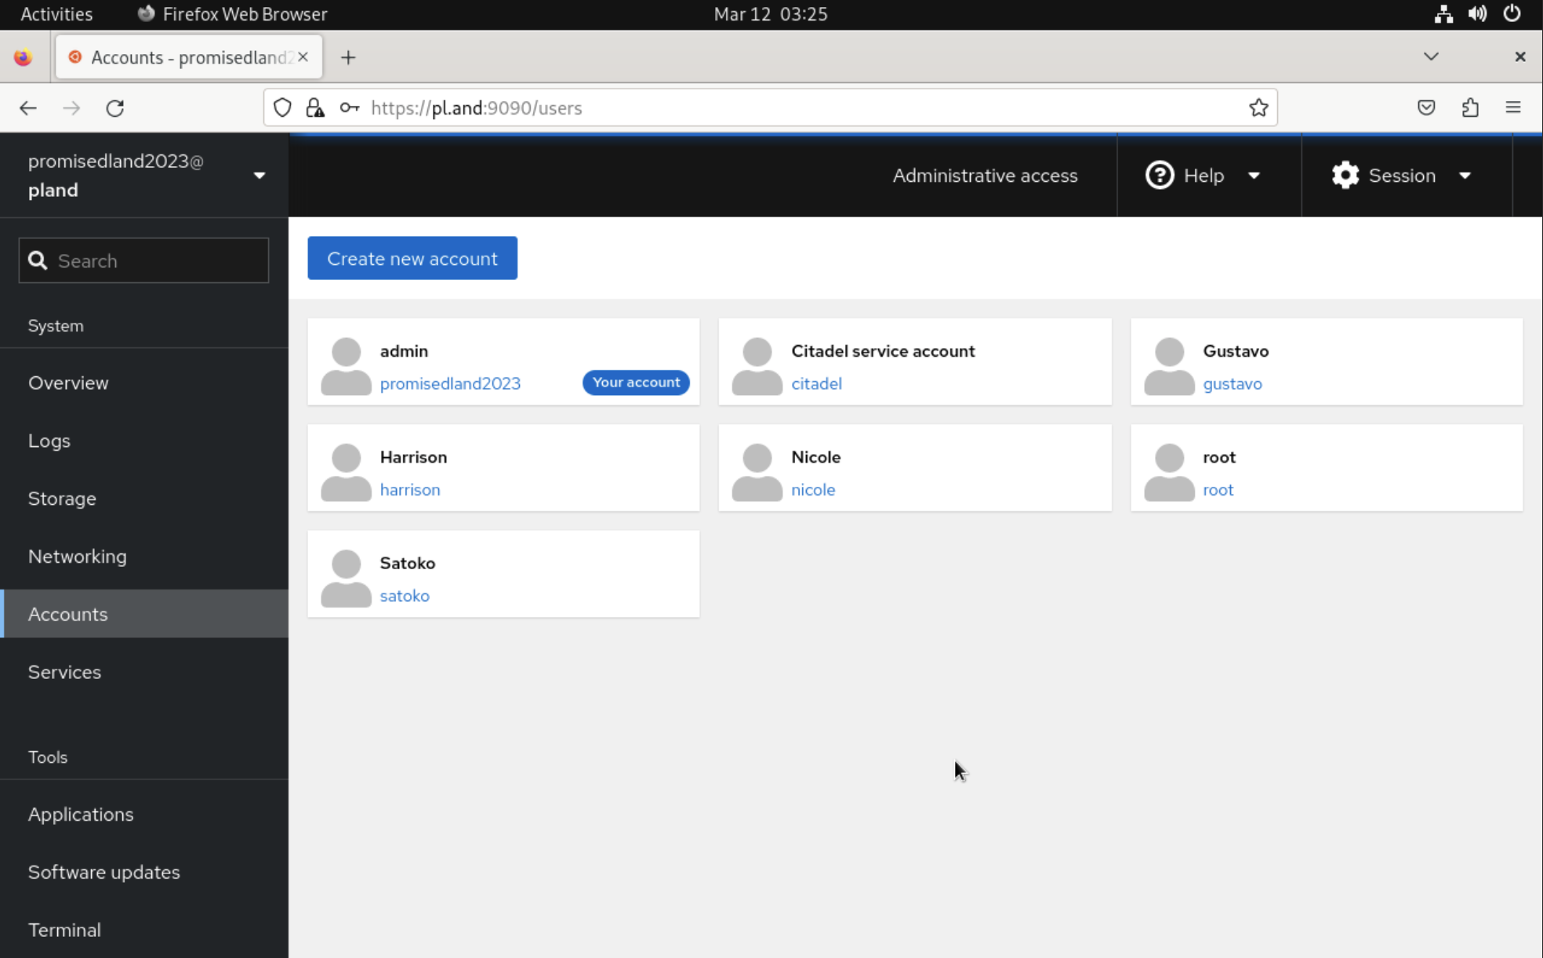

**-Monitoring Metrics and History (** [**https://192.168.169.55:9090**](https://192.168.169.55:9090) **or** [**https://pland:9090**](https://pland:9090) **)**

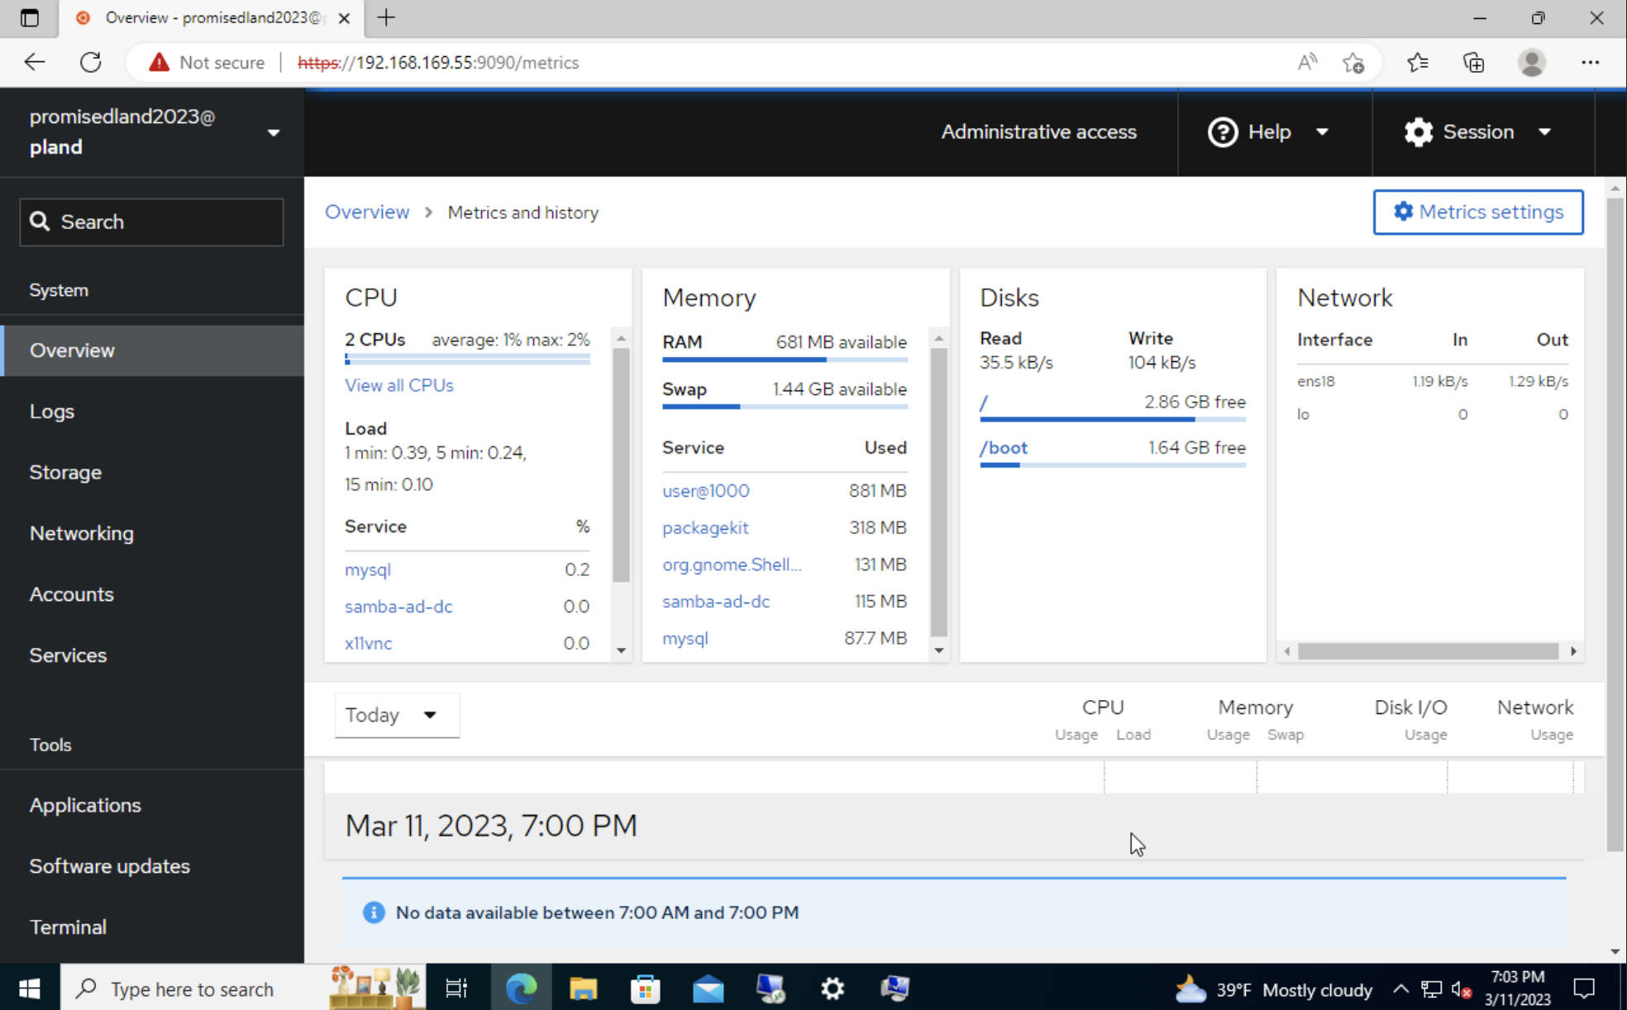

**-Mail Server Users (** [**https://192.168.189.55**](https://192.168.189.55) **or** [**https://pl.and**](https://pl.and) **)**

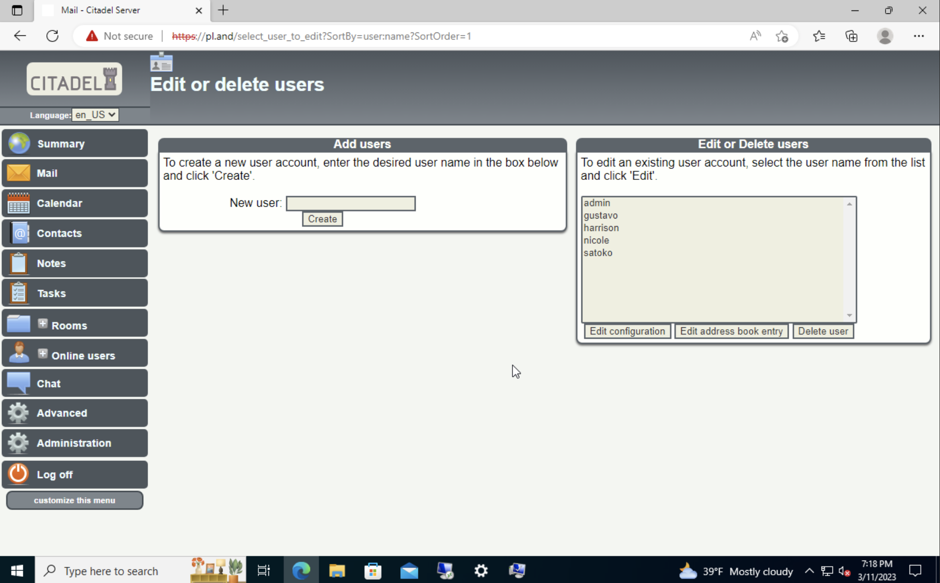

-Mail Server (sending an email from admin to Satoko) ( <https://192.168.189.55> or <https://pl.and> )

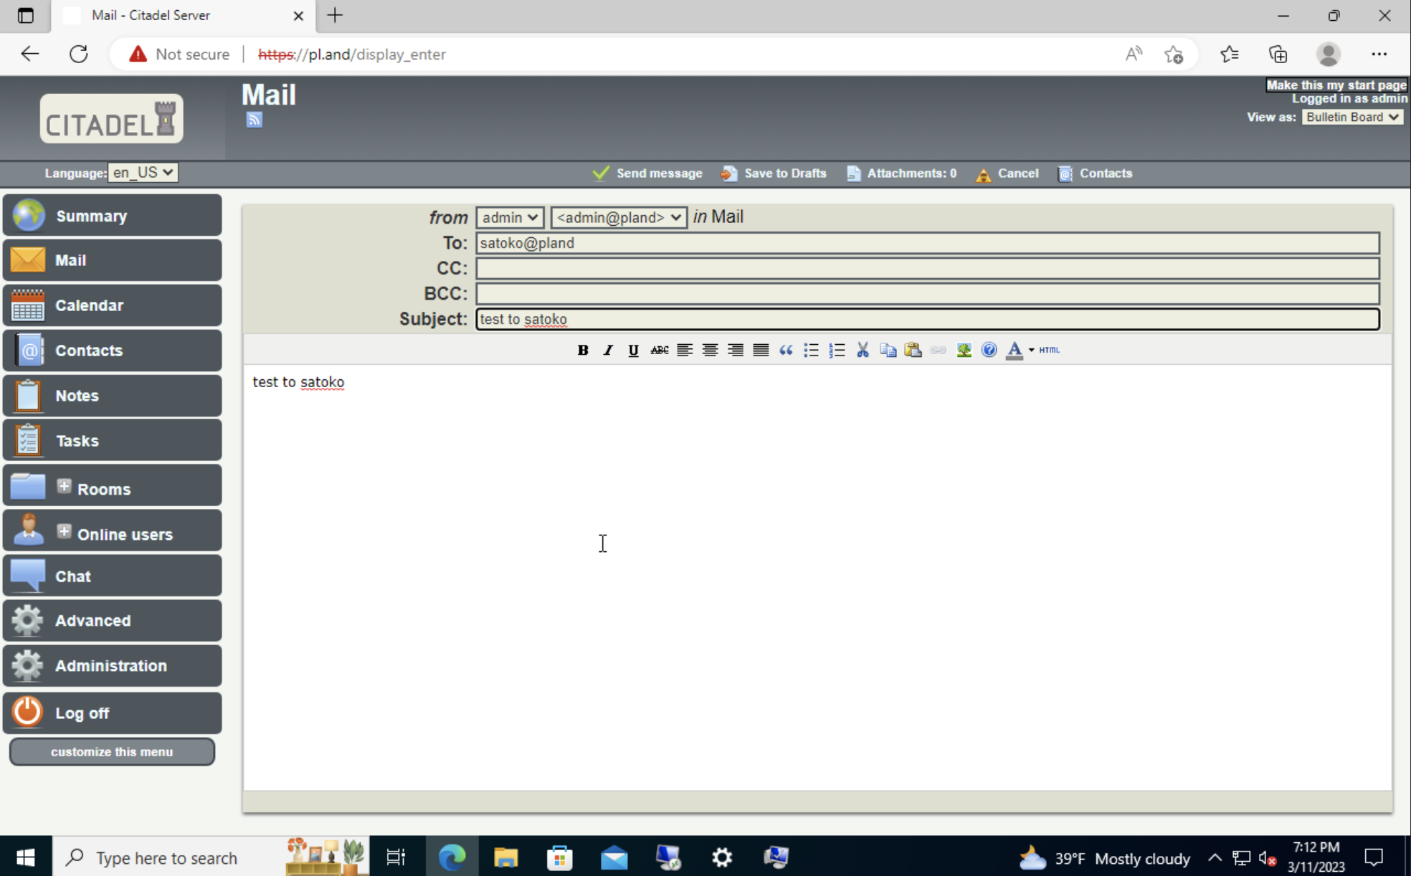

-Mail Server (Satoko received the message from admin) ( <https://192.168.189.55> or <https://pl.and> )

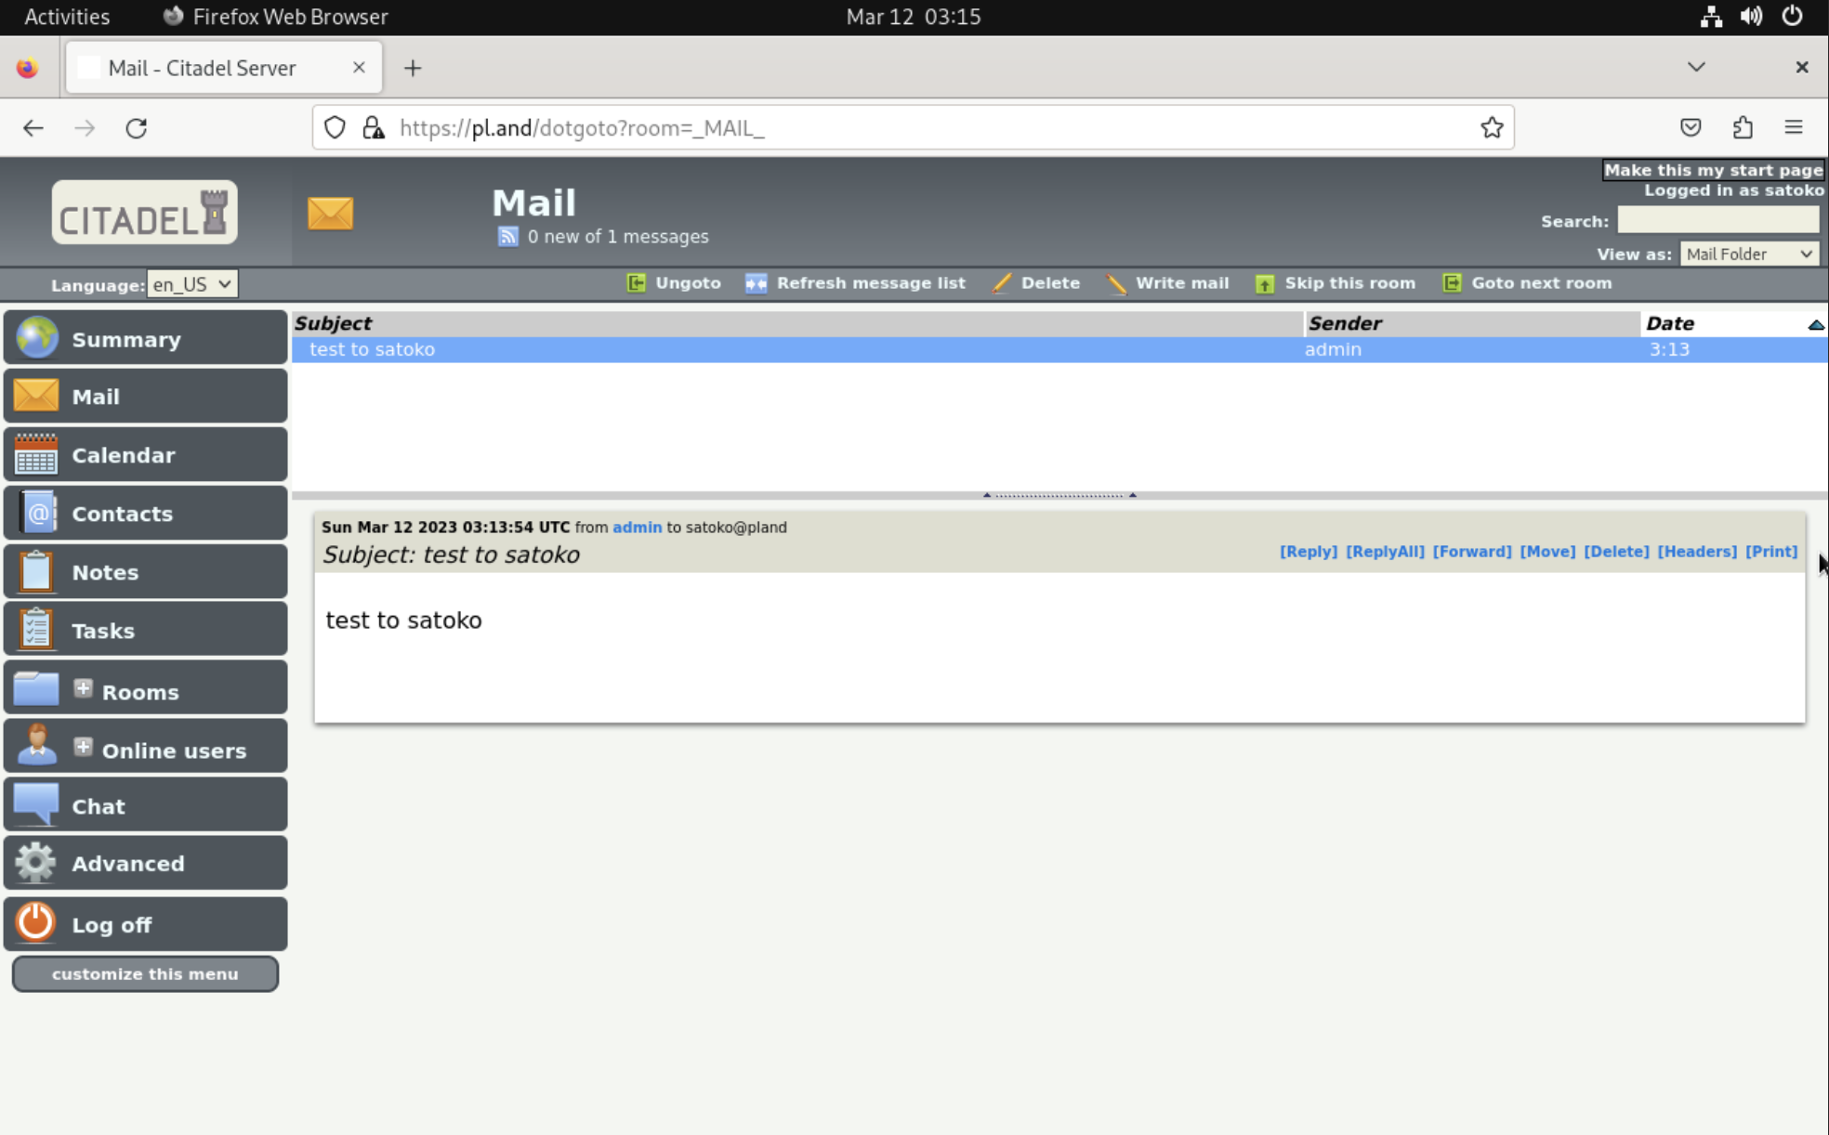

-Printer Server (CUPS configuration Terminal)

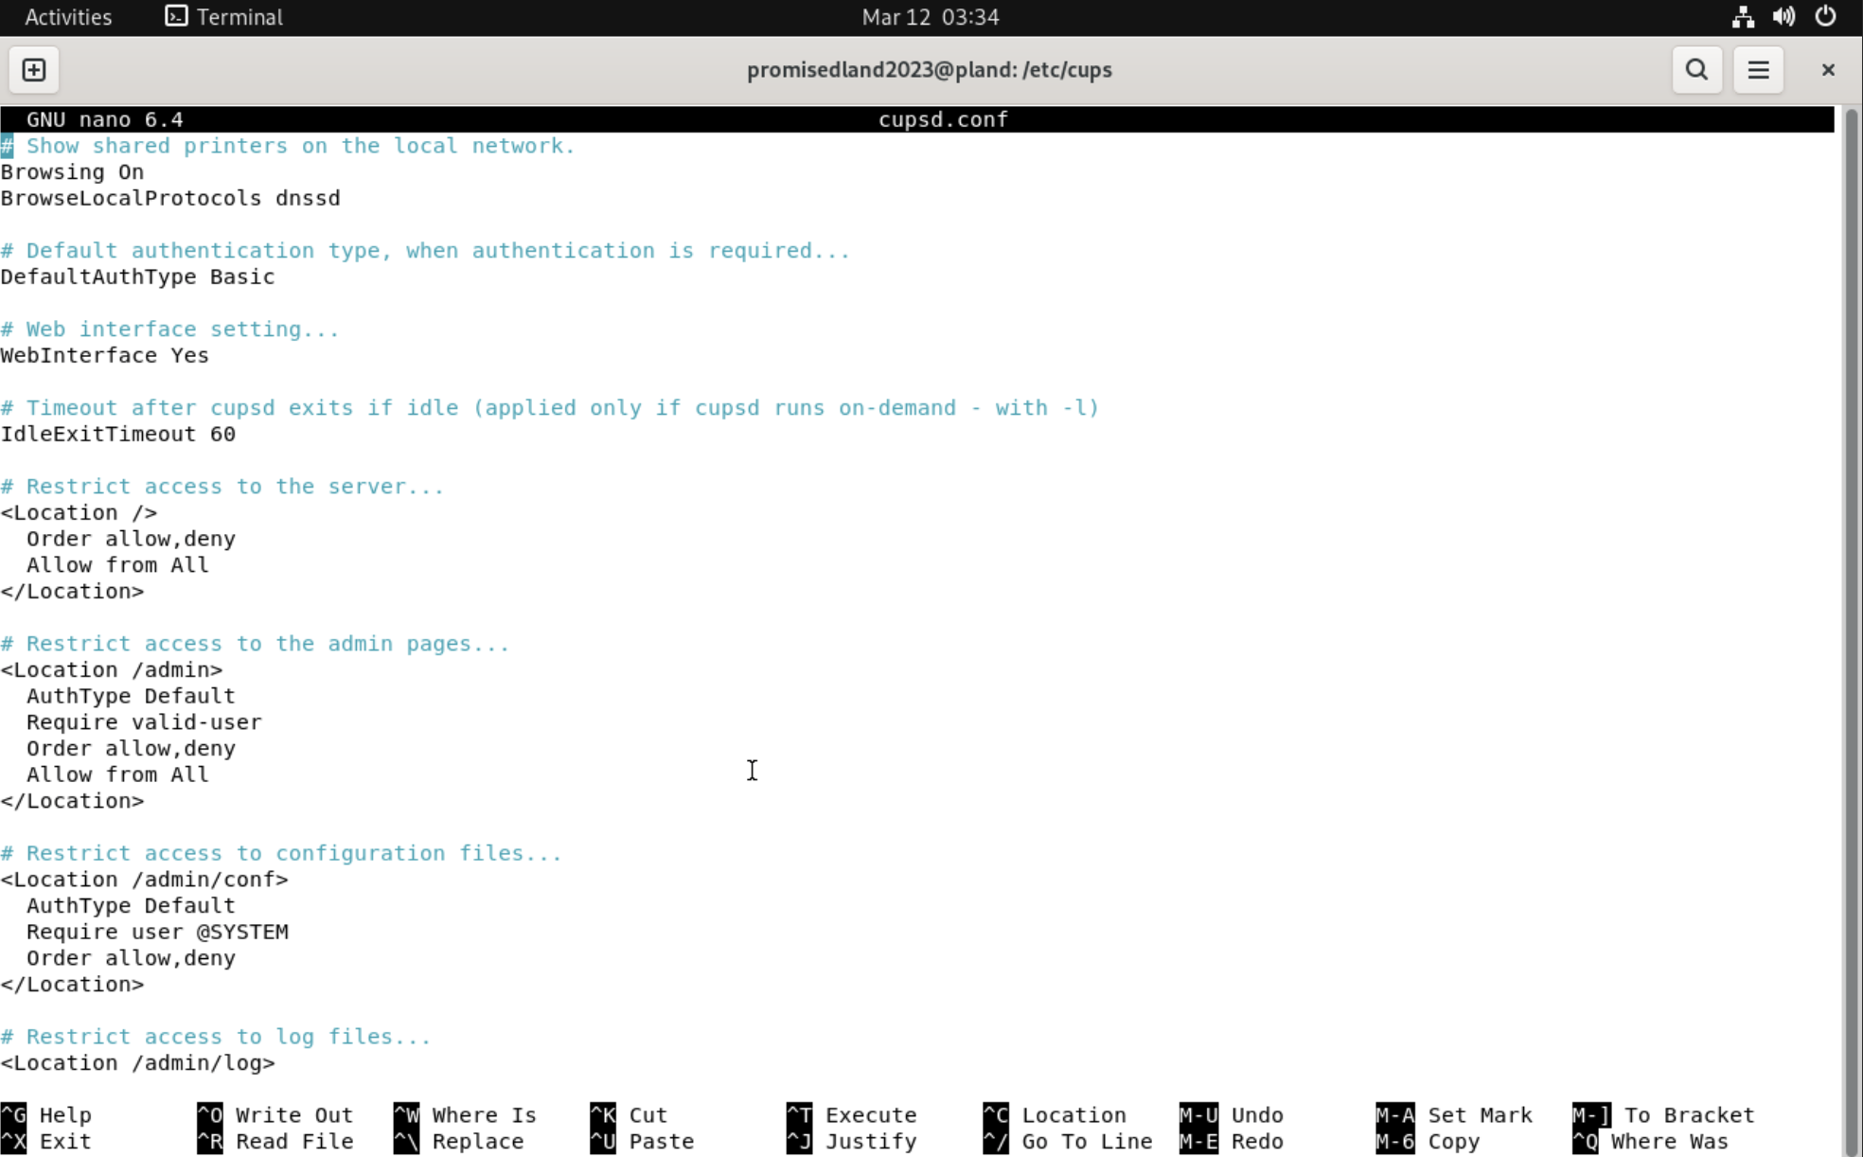

-Printer Server Log in( <https://192.168.169.55:631> or <https://pland:631> )

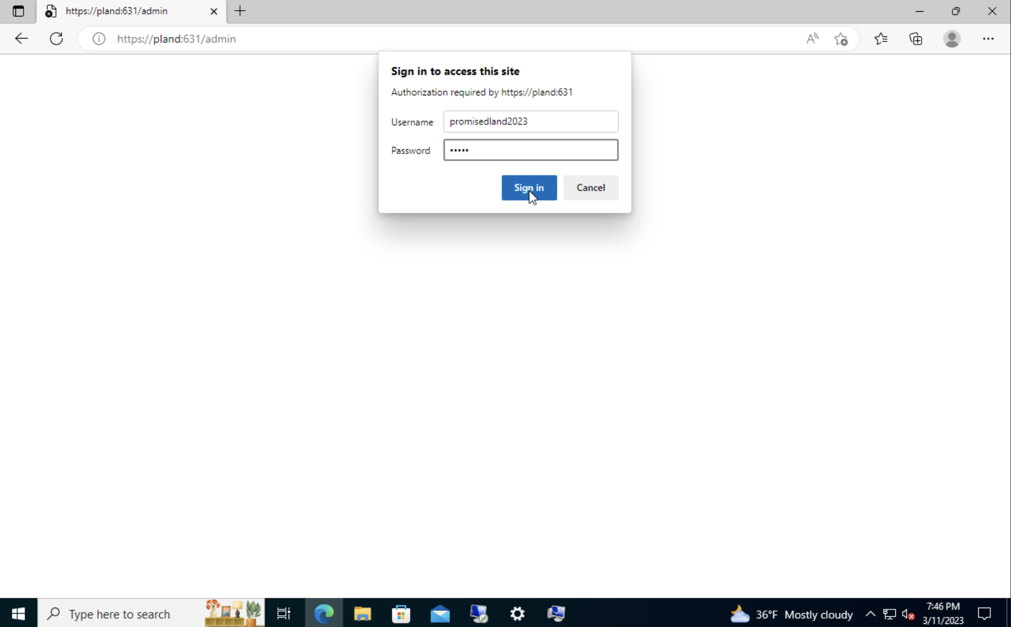

-Printer Server Add printer 192.168.168.203 ( <https://192.168.169.55:631> or <https://pland:631> )

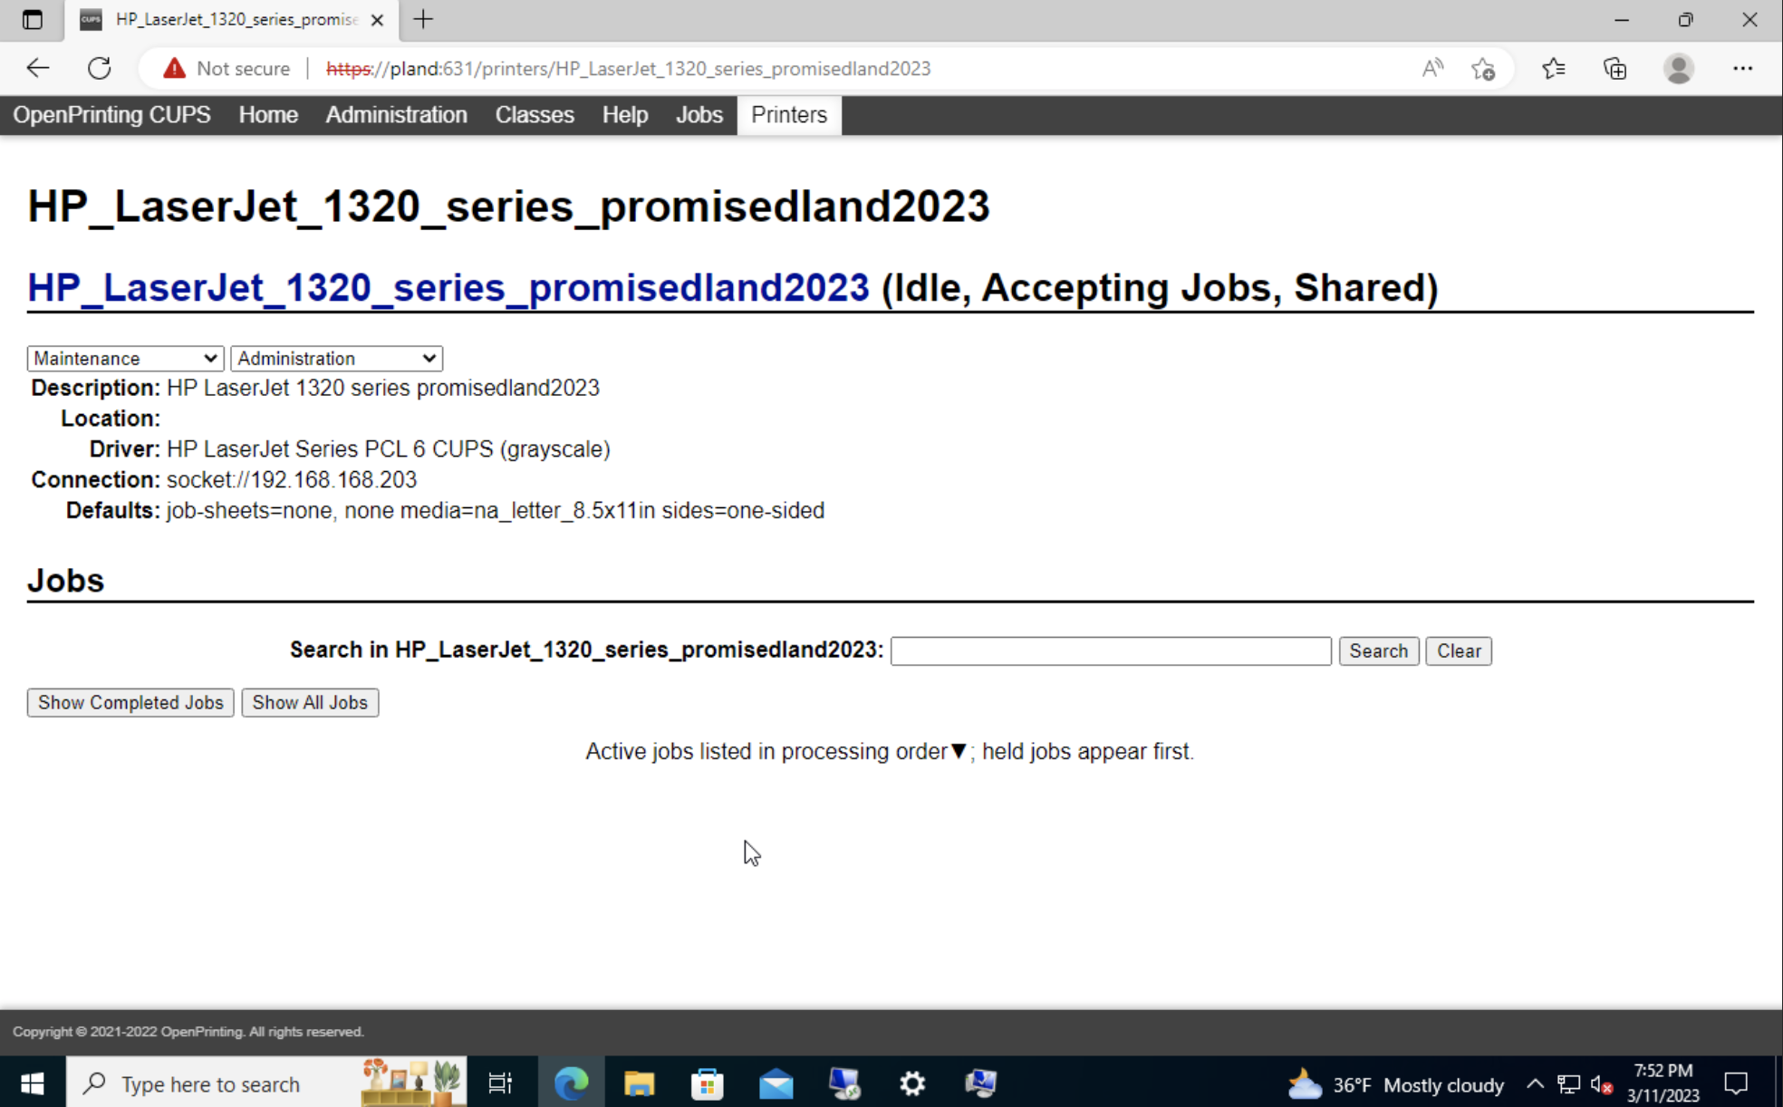

-Printer Server Printer Active( <https://192.168.169.55:631> or <https://pland:631> )

